India tour 14-30 November 2018
Bikaner in Desert
Day 5 bus to Bikaner, located west from Mandawa, half way between there and Jaisalmer, about 191klm. Bikaner is known as the “heart of the desert” city. Leaving Mandawa on the bus by 8.15am was achieved after a wakeup call at 6.30am and breakfast as a basic affair with several spicy Indian dishes and a few western dishes to choose from. Alan’s choice, cereals, fruit, toast and omelette made by a chef with instructions to hold the chili!
First 60klm on the road, the bus had to transverse shocking conditions as there were long stretches of road works being undertaken. No road sealing, many diversions, many pot-holes nearly as big as the bus. The driver had to negotiate this as well as avoiding passing trucks, camels drawing carts, people on motorbikes and bicycles plus wandering cows! This 60k took one and three quarters of an hour to complete.
A better sealed road came after the pit stop for morning tea – toilet break etc. The bus arrived at Bikaner in time for a late lunch at a restaurant nearly opposite the “Red Fort”, which was to be visited before checking into the hotel known as Samvit Shikshan Sansthan, Gandhi Colony, Samta Nagar, Bikaner, Rajasthan. Alan’s lunch:- mushroom soup + buttered flat bread known as mann. Drink was a local beer as one has to be careful about drinking any water.
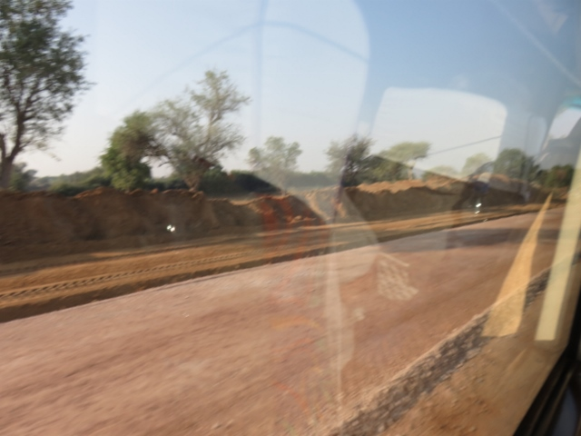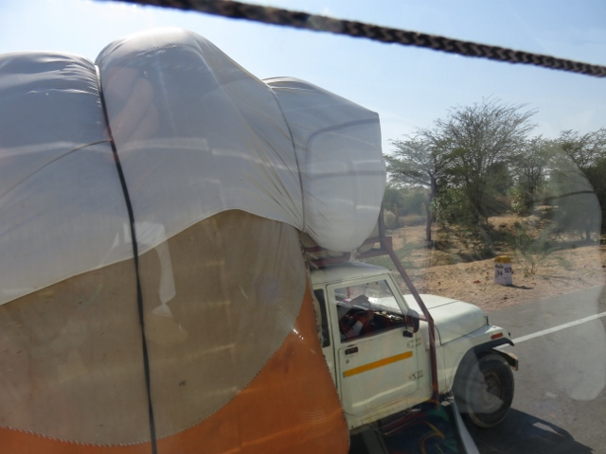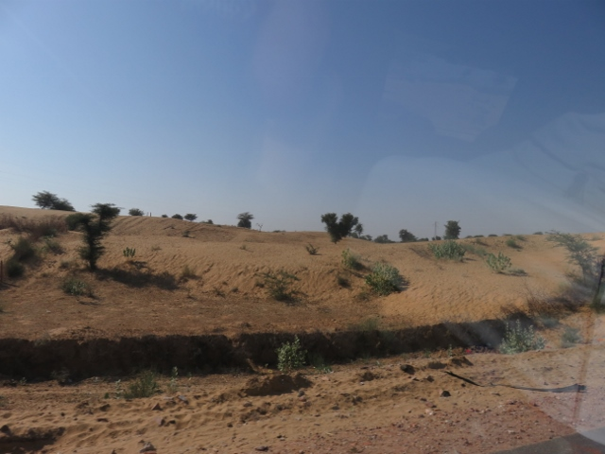
Better section of road. Passing overloaded truck. Spindly shrubs in desert.
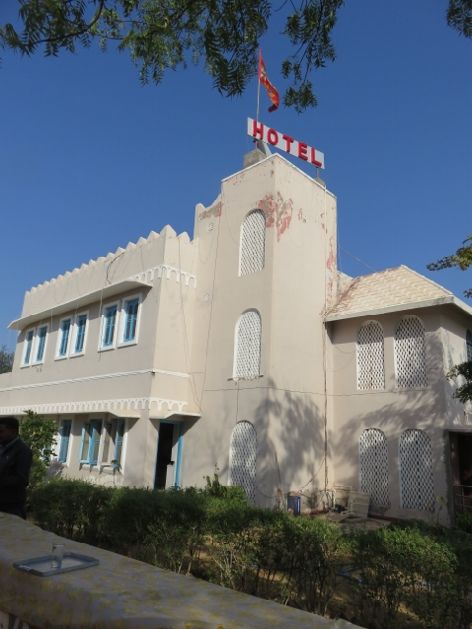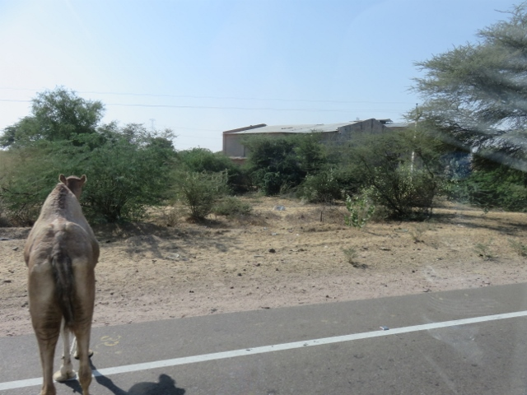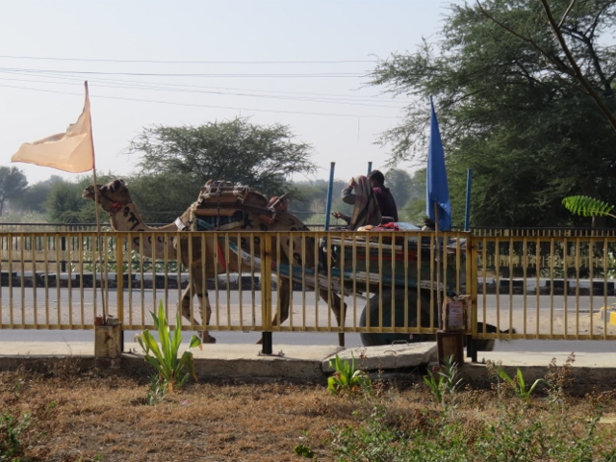
Pit stop hotel for lunch. Camel wandering across road. Camel cart hazard on road.
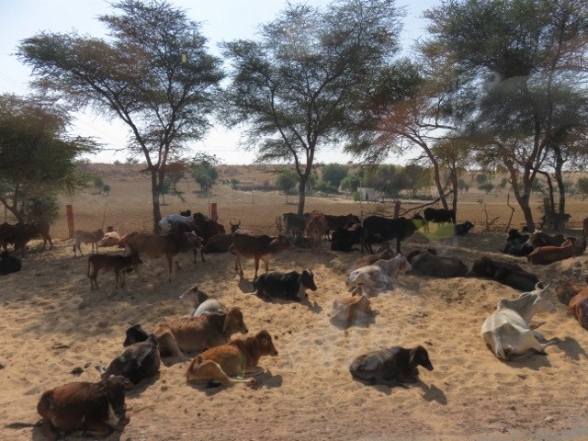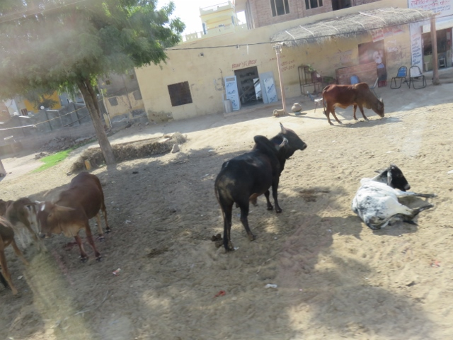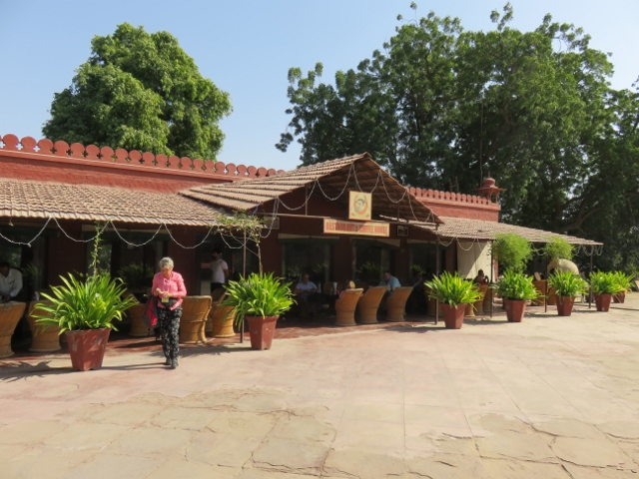
Farmer’s cows ready for milking. Wandering bulls in a village. Bikaner lunch restaurant.
The Red Fort entrance was amazing. Again built with the red sandstone on a massive scale with entrances twisting around to slow any enemy attack. Huge metal gates with spikes outwards to hinder any elephants used in attack. Inside the fort was very impressive with many alleyways with residential buildings on either side. It is still used as residences for people living there. The group climbed up the steep access route to a look out to take some photos.
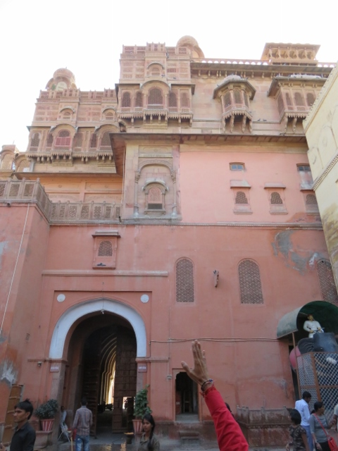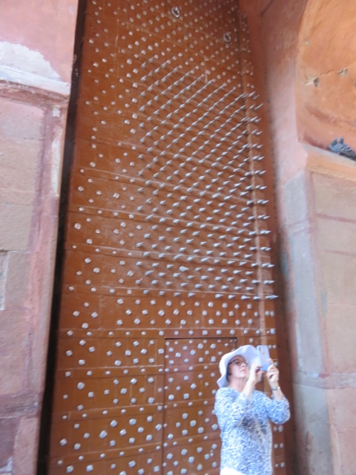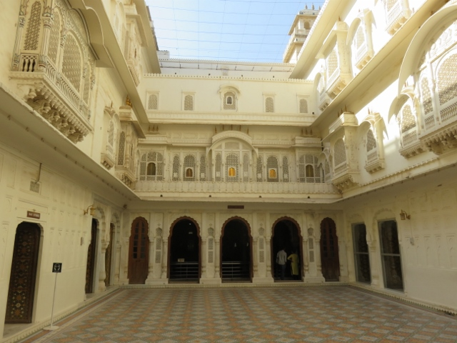
Inside outer wall of Red Fort. Massive spiked gate. Inside court yard of Moghul quarters.
After the inspection of the Red Fort, Harch, the tour guide arranged for the group to be taken by the bus to a village about 40 minutes south of Bikaner. This place has a Hindu temple and shrine dedicated to the goddess of rats! UGH!!To get into the shrine area (fenced off) one has to take off shoes and socks and walk in barefoot. A shoe Waller guards the shoes until one exits the complex. A small container of seeds can be purchased to feed the rats. Queued up to get in one shuffles along in the crowd throng with hundreds of rats scurrying everywhere. One ran over Alan’s foot and that was supposed to be a sign of “good luck”! In the Hindu religion, reverence is given to the rats because they believe that they could be one of their ancestors. Giving them food and shelter is supposed to earn brownie points (Alan’s term) for the believers.
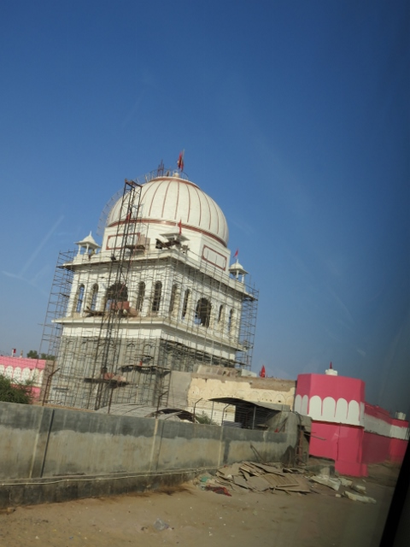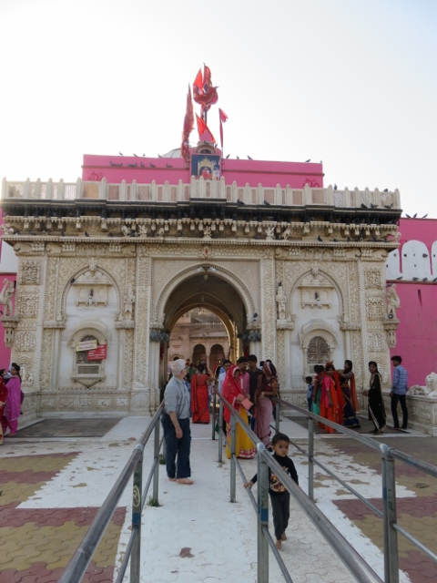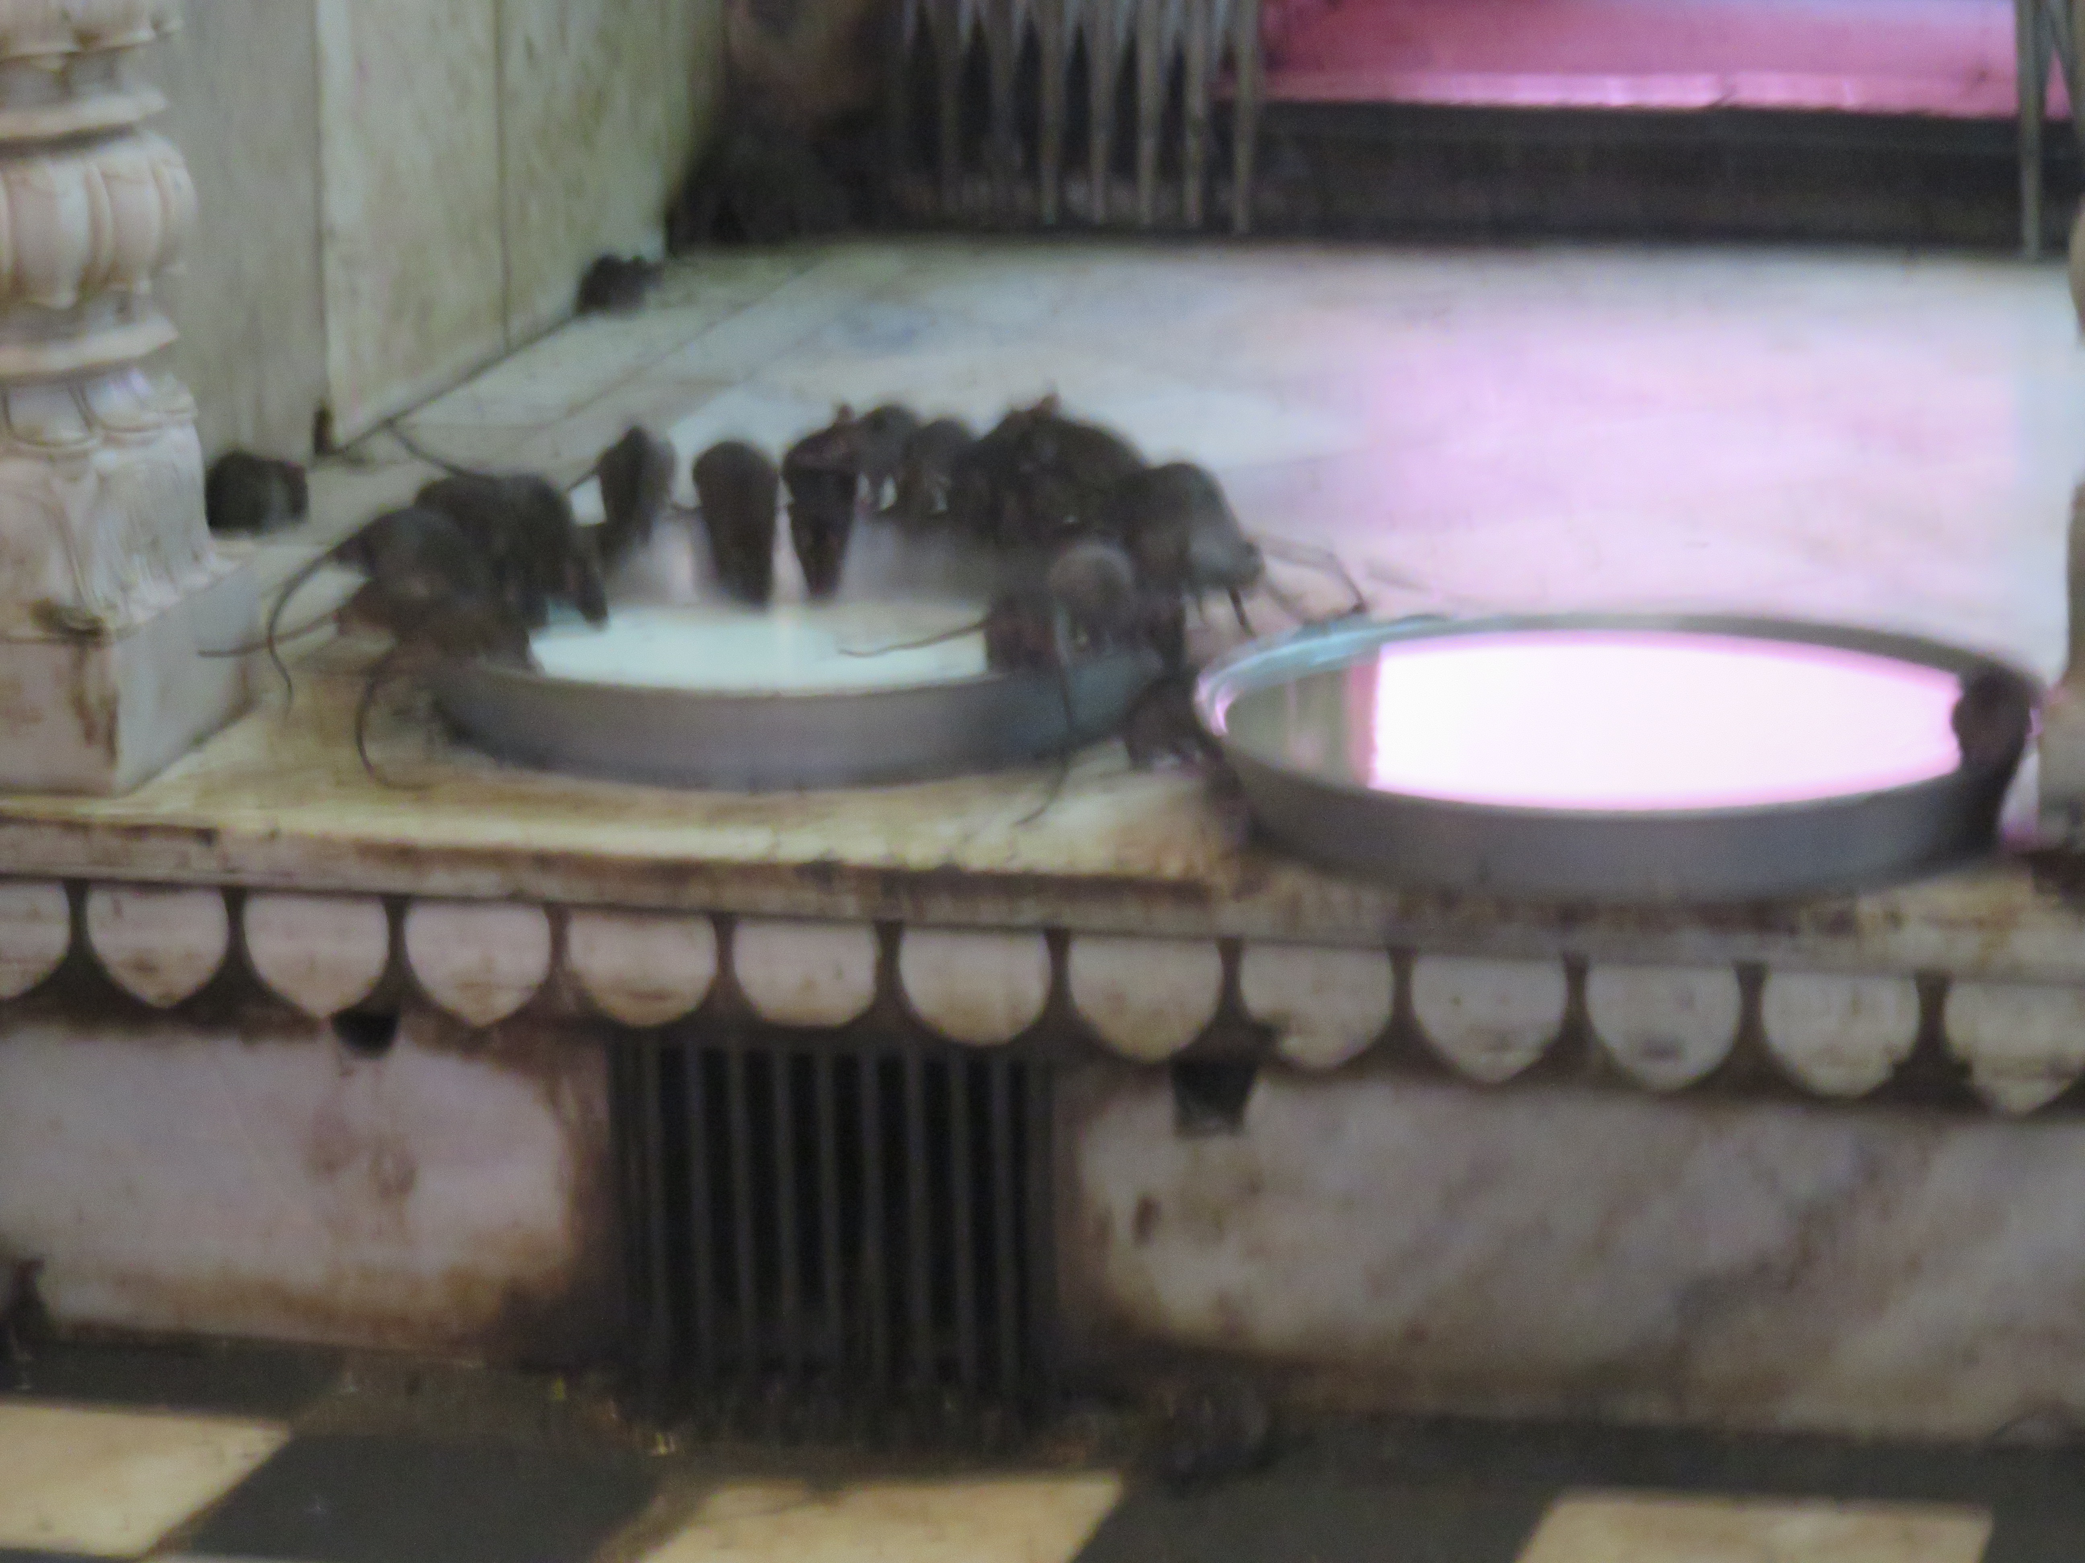
Hindu temple dedicated to rats. Entrance to shrine with bare feet. Some of rats drinking milk.

Once out of the complex, an area was provided to well and duly clean off any residue from the barefoot experience! Back on the bus then for the drive to the hotel. Harch, (Indian tour guide) said it was a basic room with a shower and toilet. He was being facetious as the rooms were as big as the lounge and kitchen back home combined. A nice touch was a bugler welcoming the bus on arrival outside the reception area.
Check-in completed and Alan allocated room 112. Dinner at 7.30pm was the usual buffet affair. Later Father Max conducted a Sunday service for the group in his room 104. Everyone attended including the Indian tour guide. Into bed by 10.30pm.

